Navigation Diagram

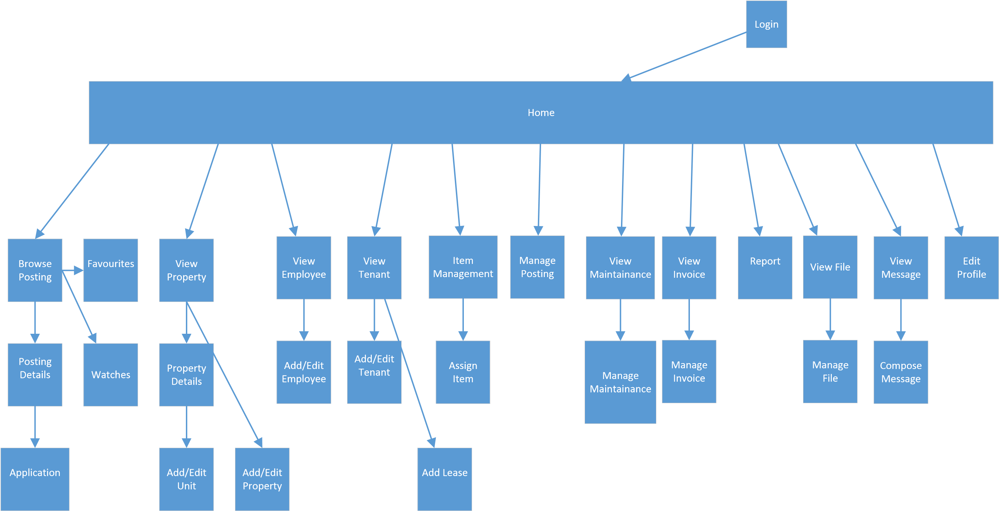

Figure : Navigation Diagram

*Note: this is just an example. Replace it with appropriate diagrams*